**Fatima Jinnah Women University**

***Department of Software Engineering***

|  |
| --- |
|  |
|  |  |

**SUBJECT: CC LAB**

**SUBMITTED TO: SIR SHOAIB**

**SUBMITTED BY: ZUNAIRA NOOR**

**REGISTRATION NO: 2023-BSE-075**

**SEMESTER: V-B**

**Task 0 Lab Setup (Codespace & GH CLI)**

**Create Codespace & connect:**

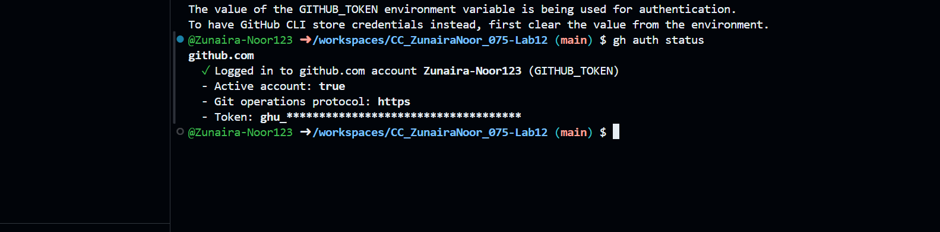

**List Codespaces**



**SSH into Codespace**

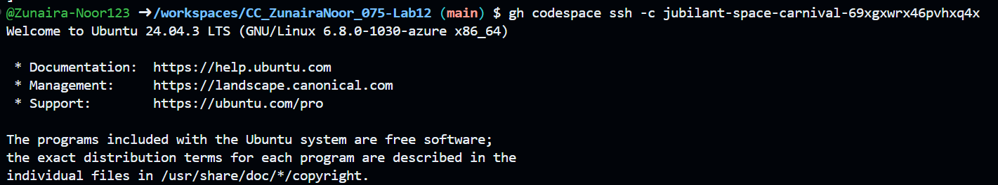

**Task 1 — Organize Terraform Code**

**Run ALL commands inside Codespace terminal**

**Step 1: Create Project Directory**



**Step 2: Create Required Files**

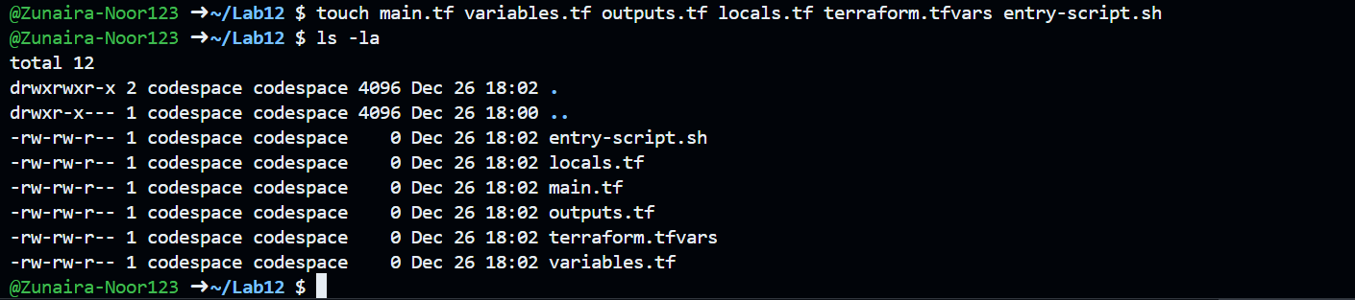

**Step 3: Create variables.tf**

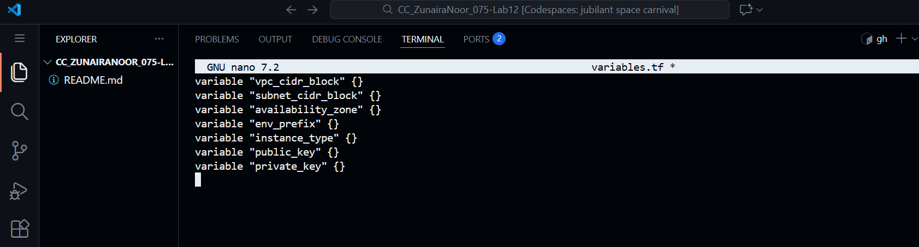

**Step 4: Create outputs.tf**

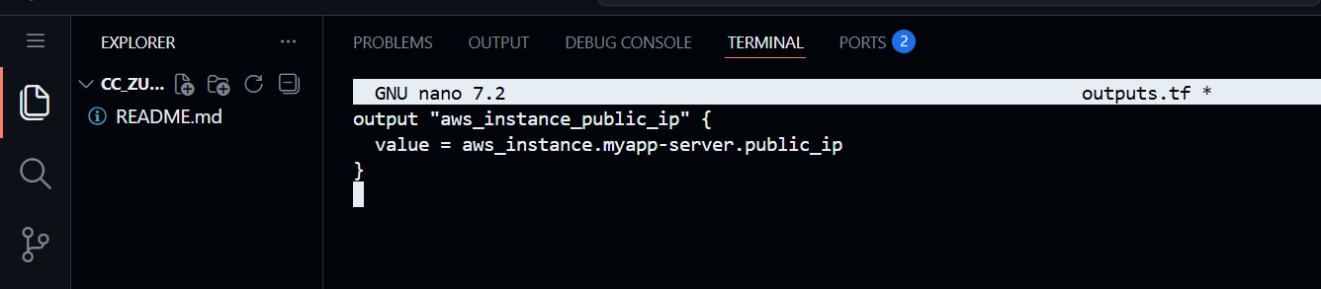

**Step 5: Create locals.tf**

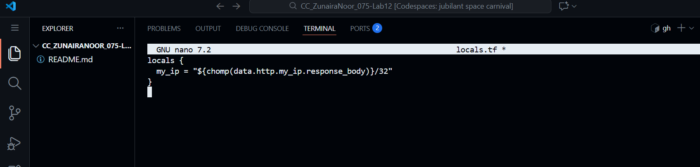

**Step 6: Create terraform.tfvars**

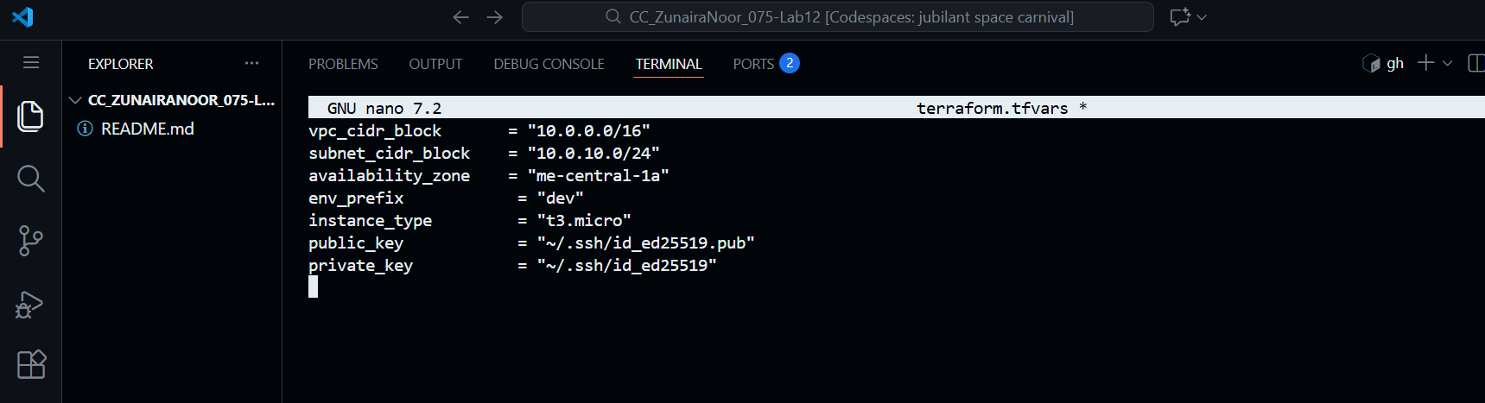

**Step 7: Create main.tf**

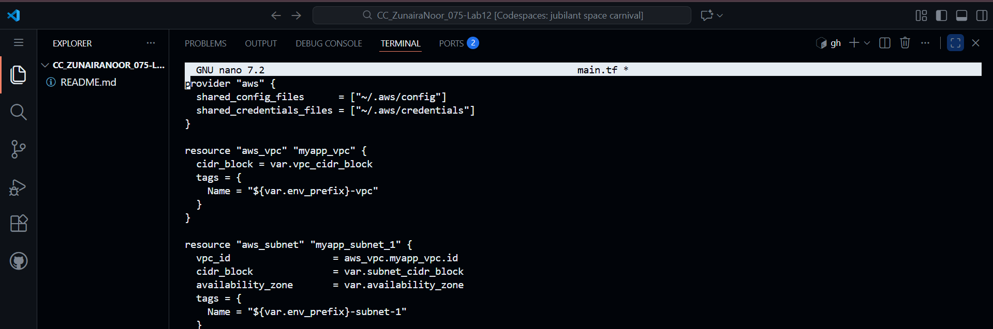

**Step 8: Create entry-script.sh**

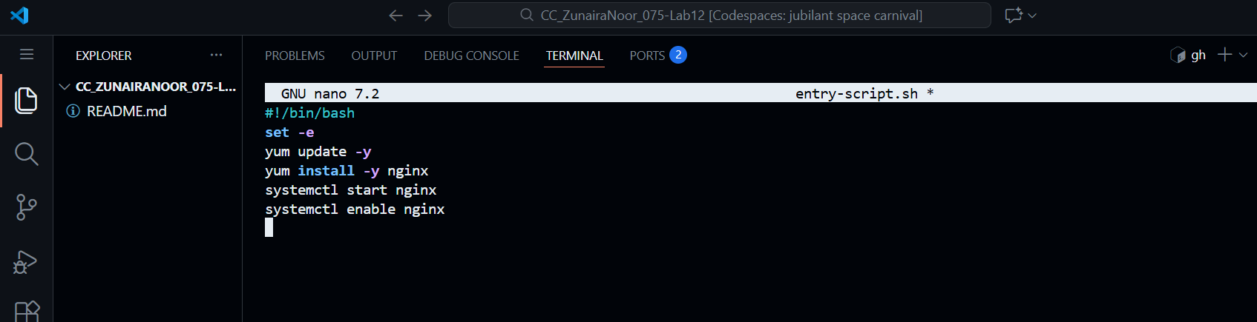

**Make executable:**



**Step 9: Generate SSH Key**

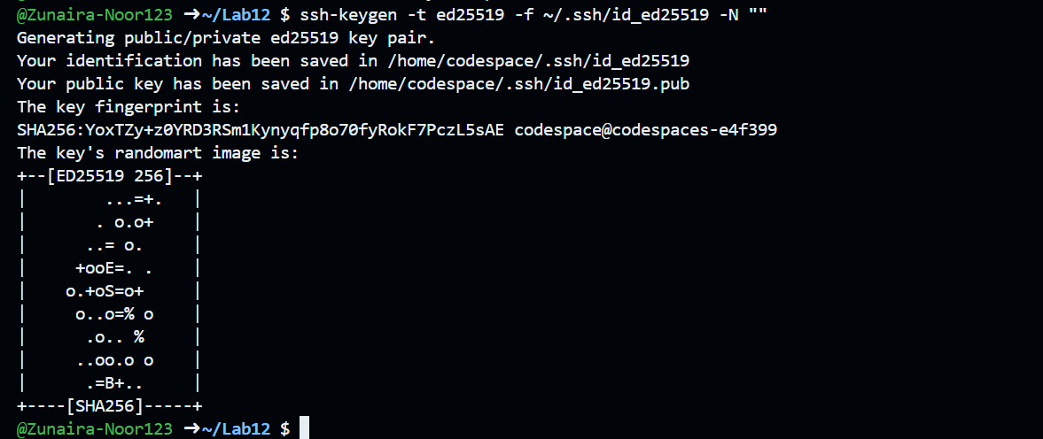

**Step 10: Initialize Terraform**

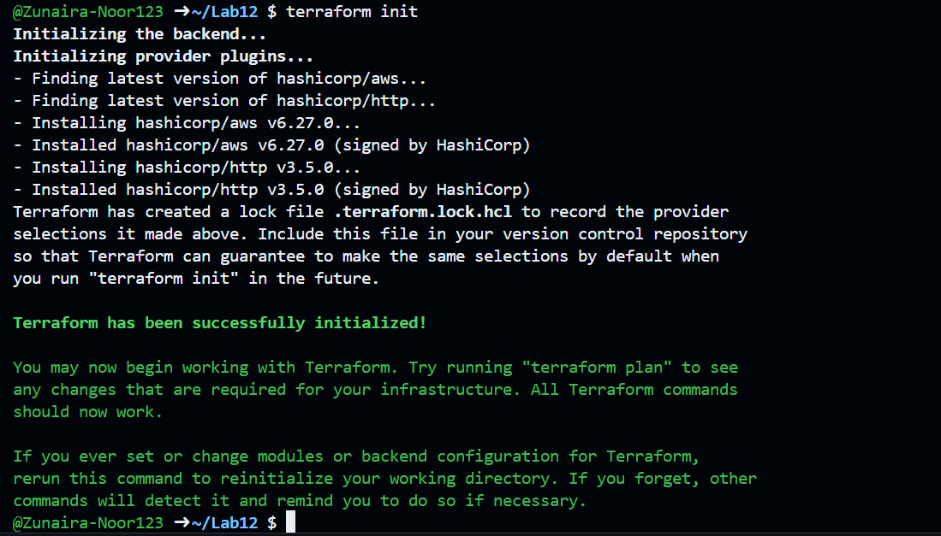

**Step 11: Apply Configuration**

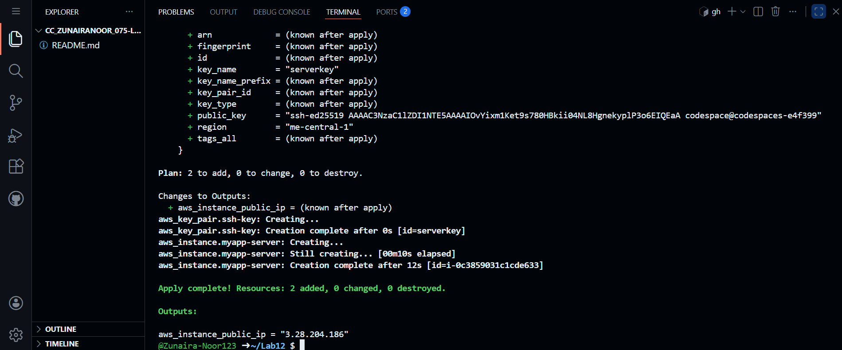

**After Apply Succeeds**



**Open browser:**

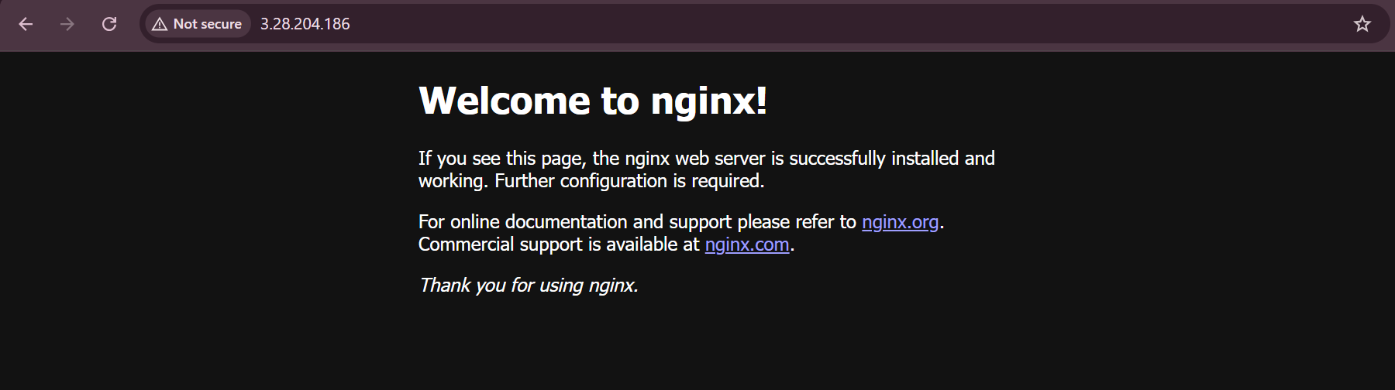

**Destroy Resources**

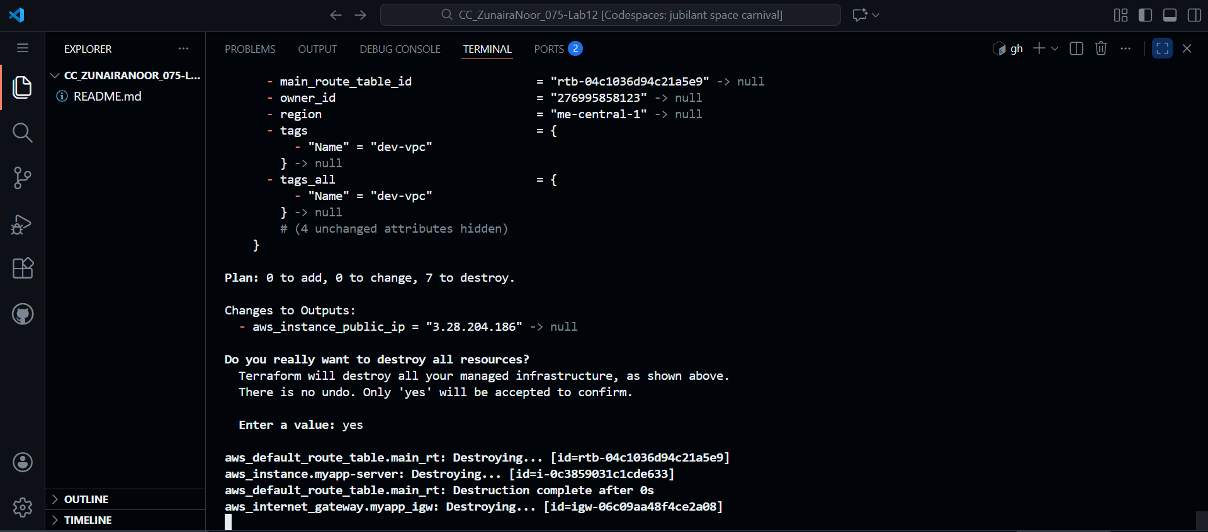

**Task 2 — Use remote-exec Provisioner**

**Step 1: Edit main.tf**

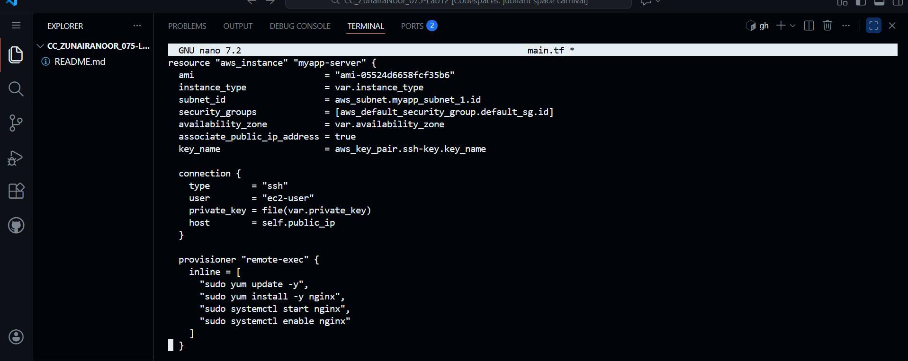

**Step 2: Apply Terraform**

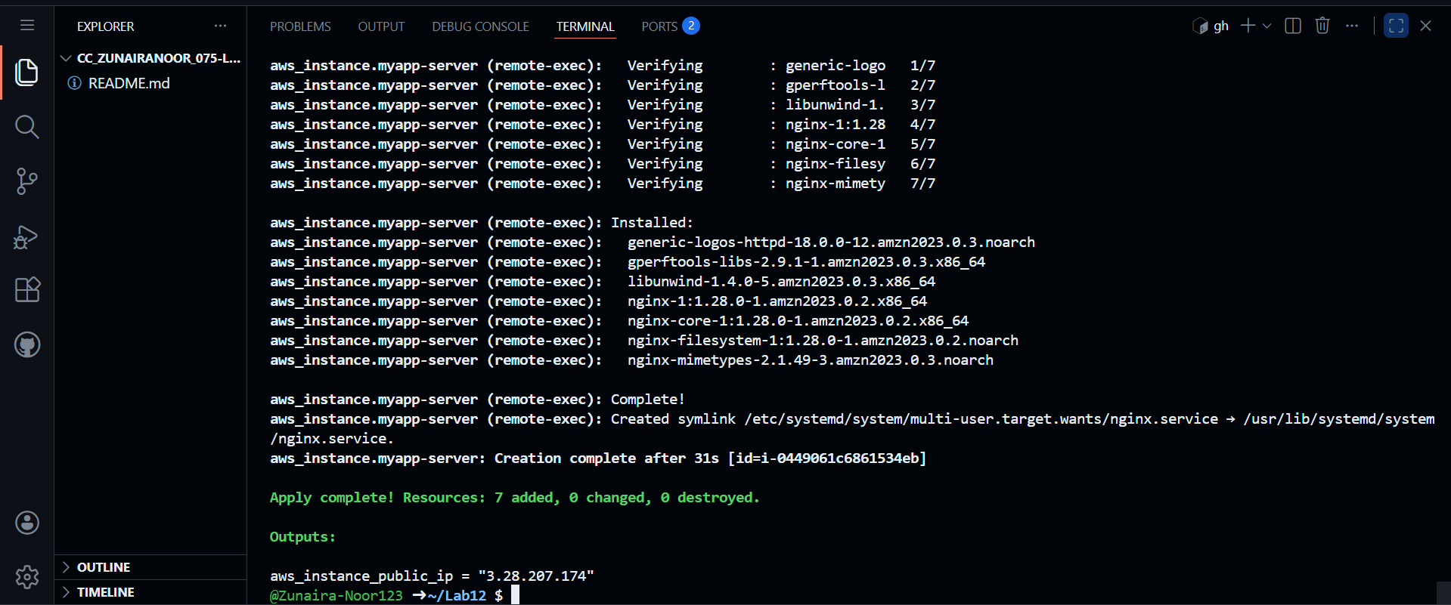

**Step 3: Display Output**



**Step 4: Test Nginx in Browser**

**Open browser and visit:**



**Task 3 — File, Remote-exec & Local-exec Provisioners**

**Replace aws_instance Resource**

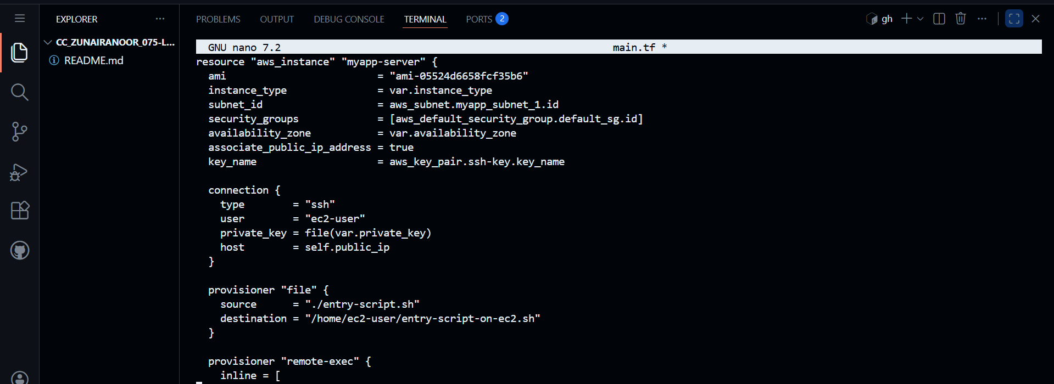

**Apply Terraform**

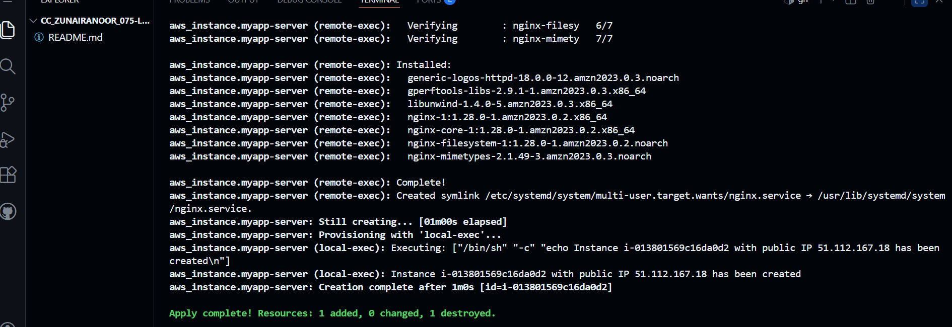

**Show Terraform Output**

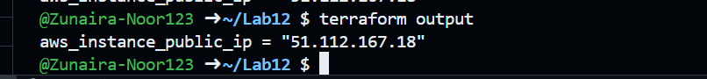

**Test Nginx in Browser**

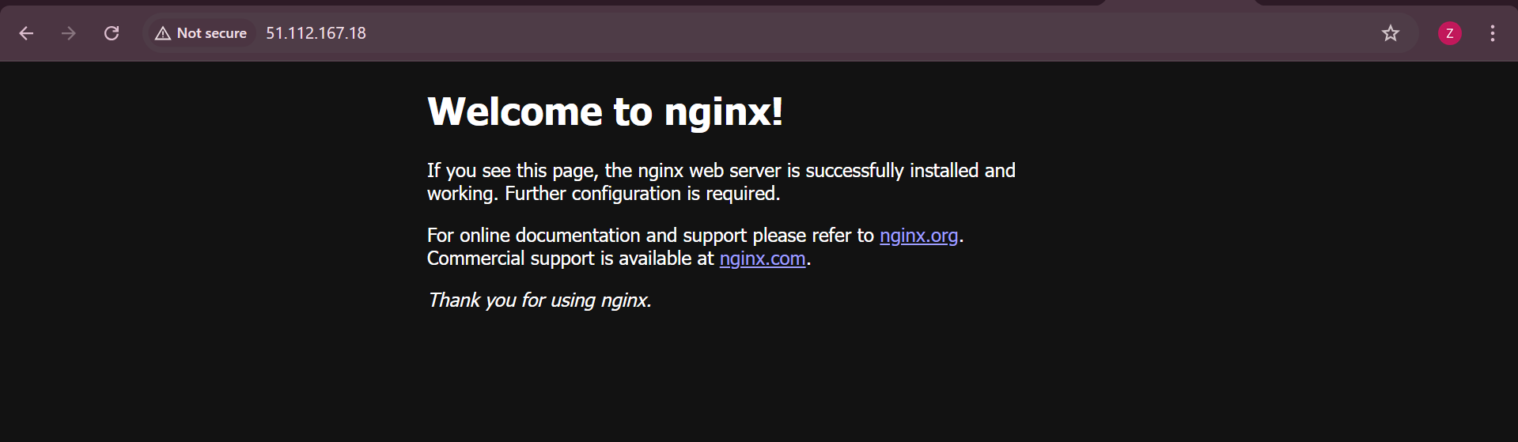

**Destroy Resources**

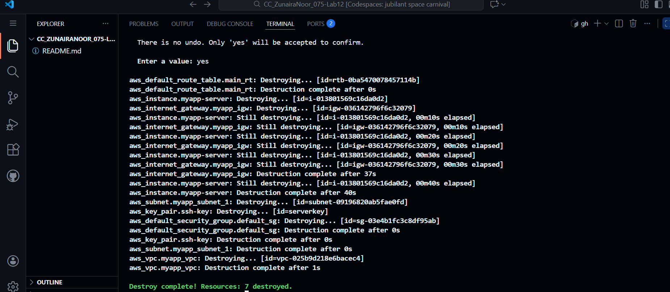

**Restore user_data (Remove Provisioners)**

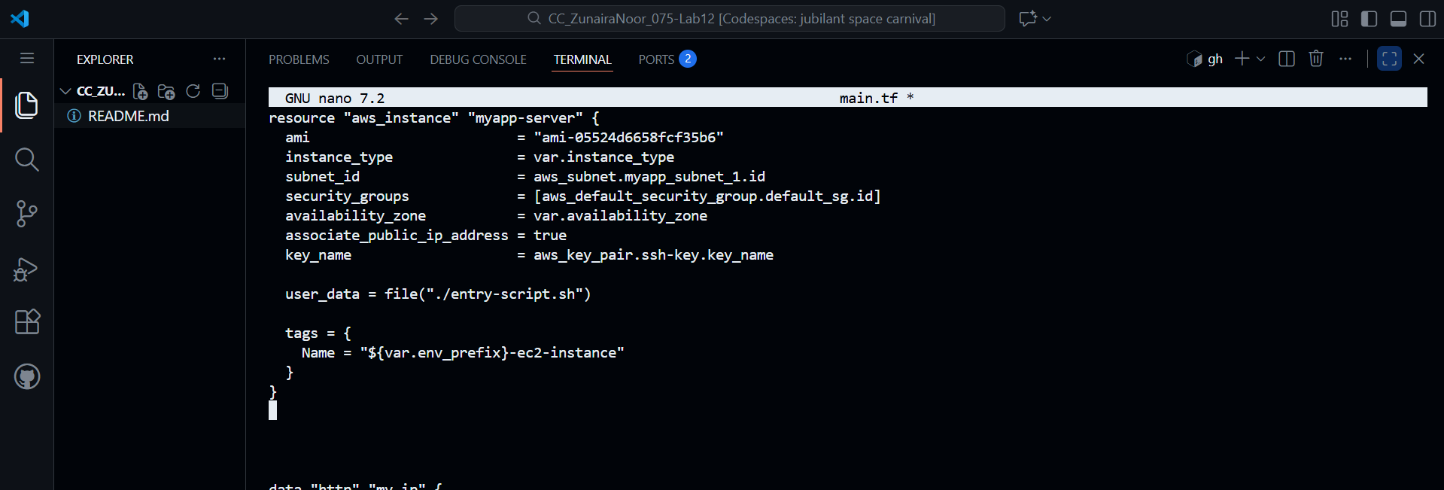

**Task 4 — Create Terraform Subnet Module**

**Step 1: Create Module Directory Structure**

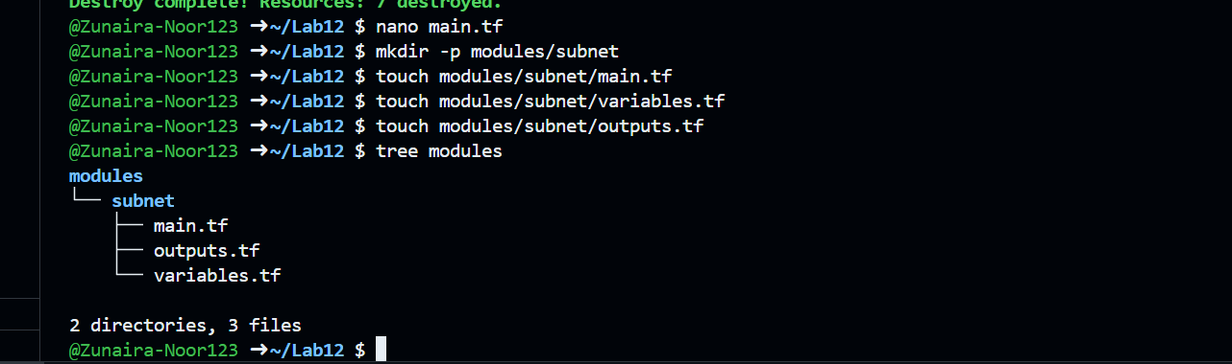

**Step 2: Create modules/subnet/variables.tf**

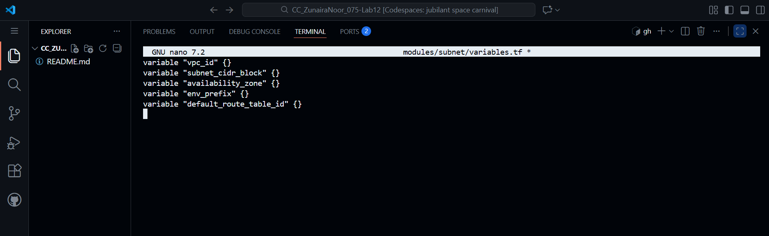

**Step 3: Create modules/subnet/main.tf**

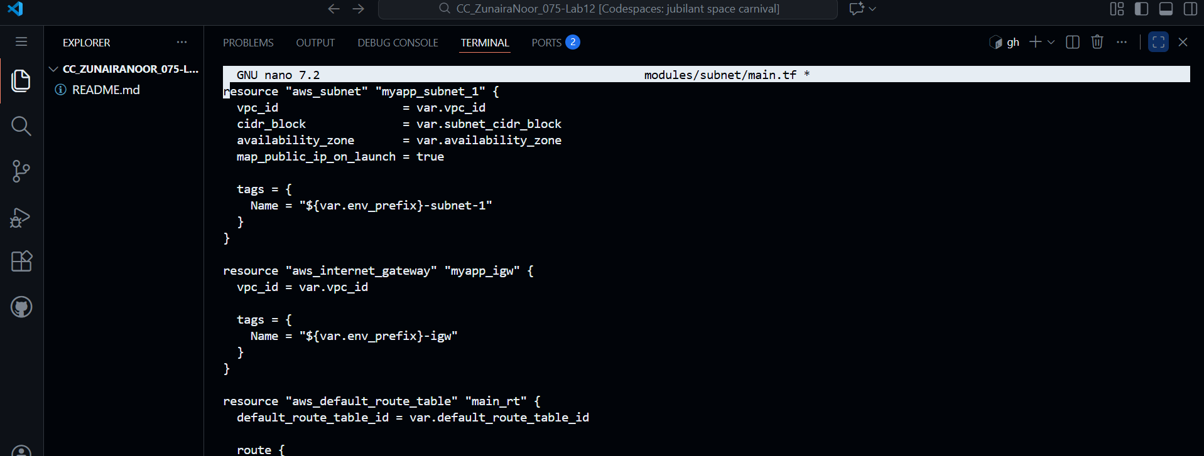

**Step 4: Create modules/subnet/outputs.tf**

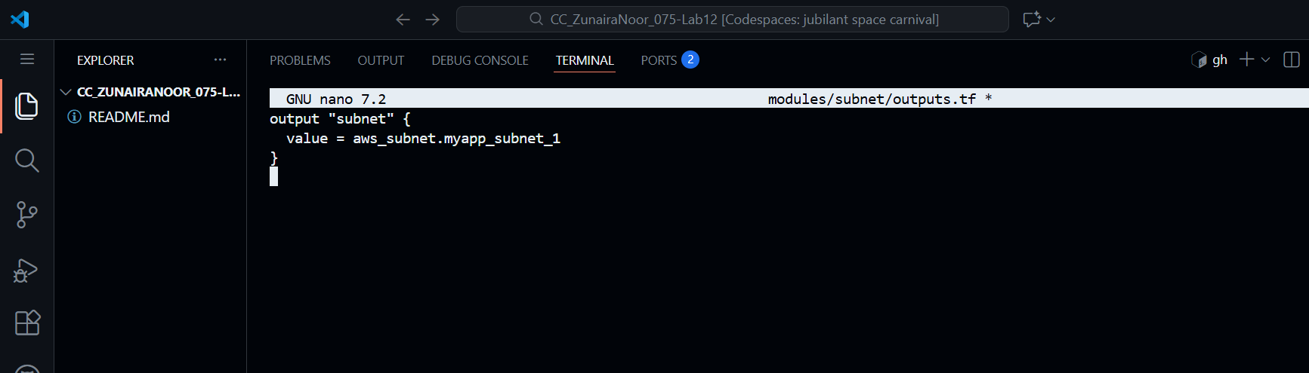

**Step 5: Modify Root main.tf to Use Module**

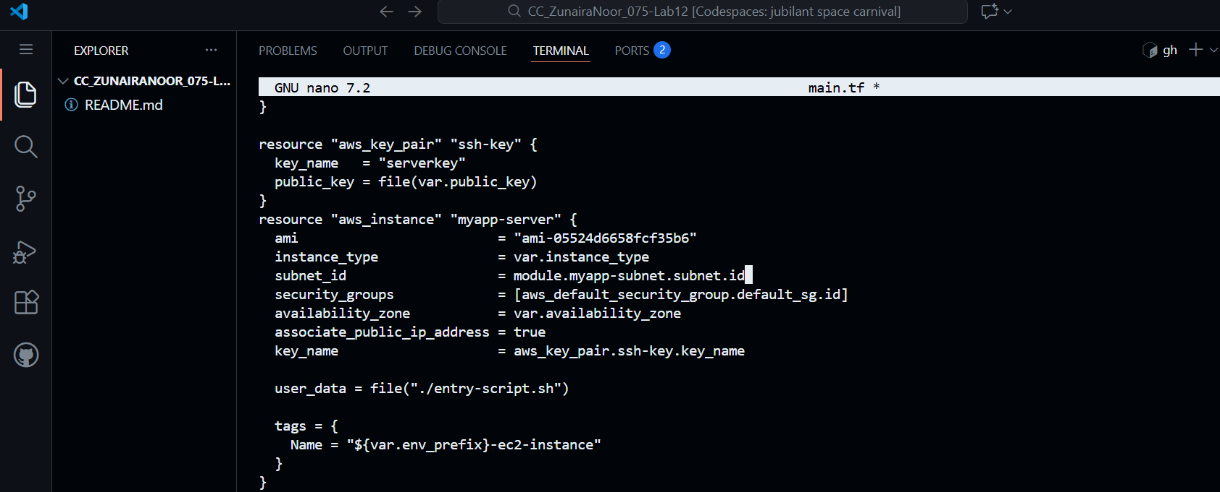

**Step 6: Initialize Terraform**

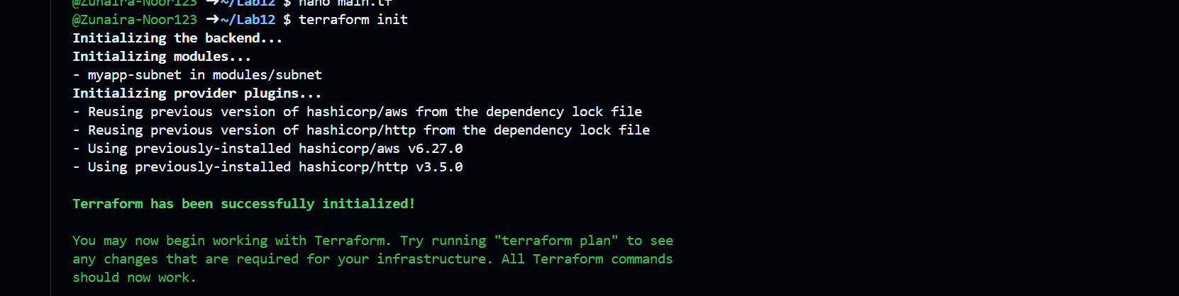

**Step 7: Apply Configuration**

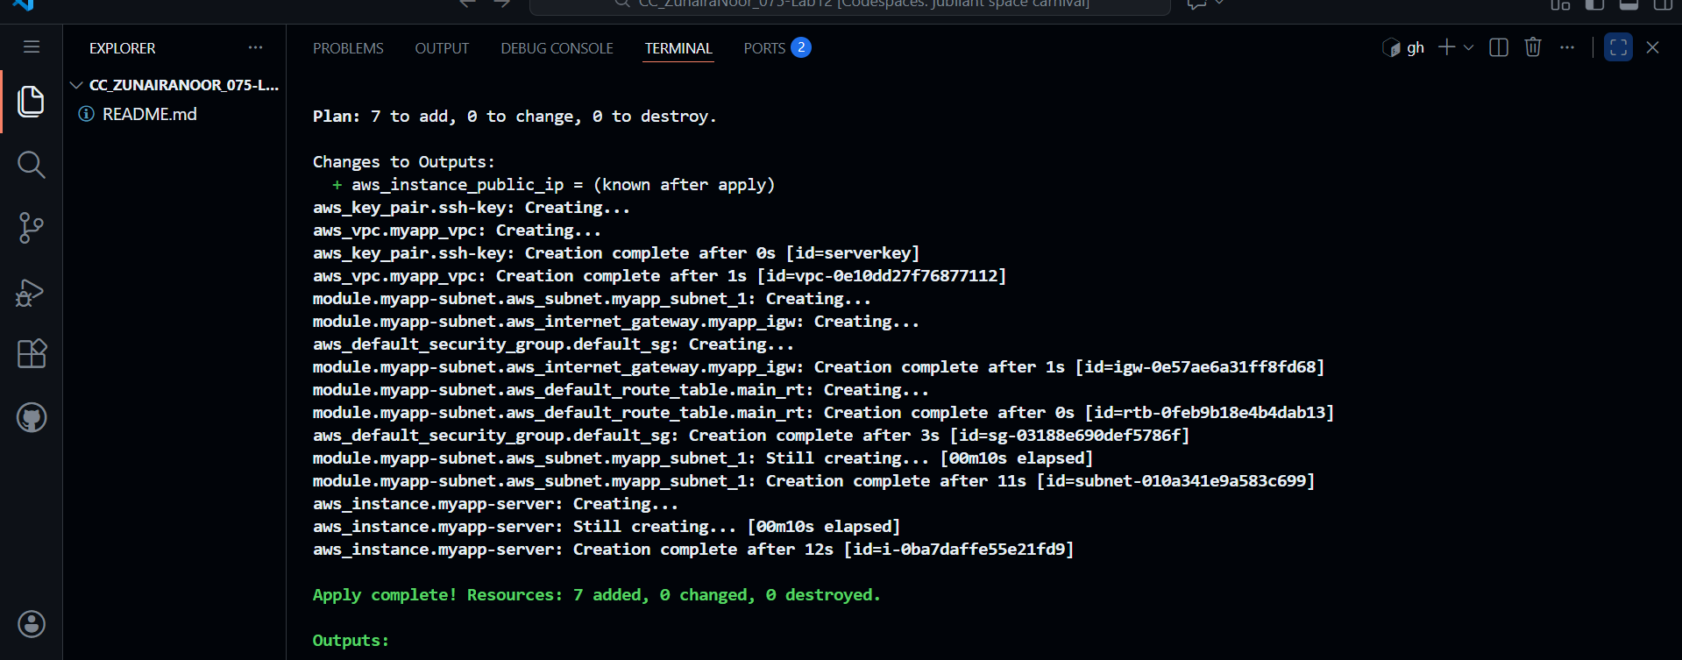

**Step 8: Show Output**

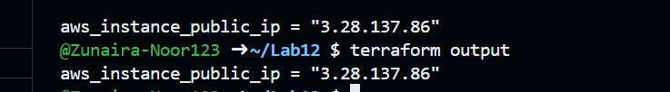

**Step 9: Test Nginx**

**Open browser:**

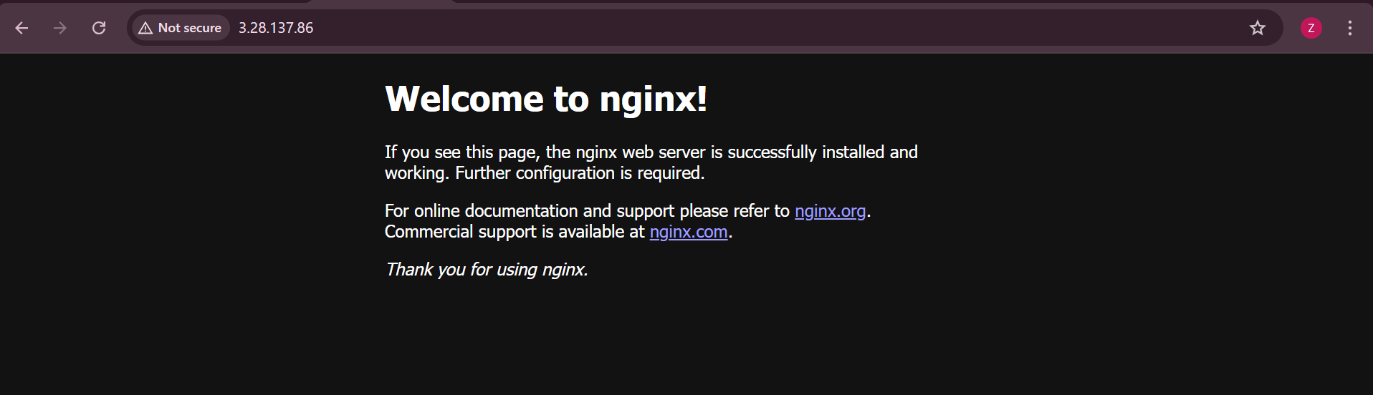

**Task 5 — Create Webserver Module**

**Step 1: Create Webserver Module Structure**

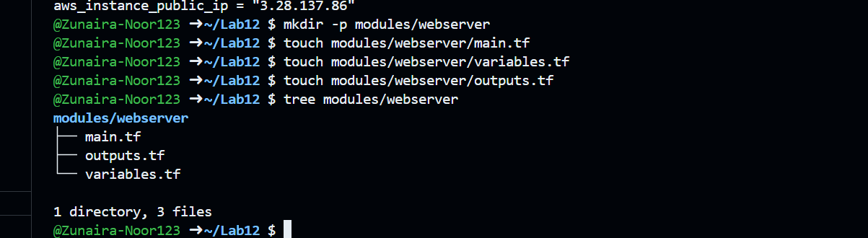

**Step 2: Create modules/webserver/variables.tf**

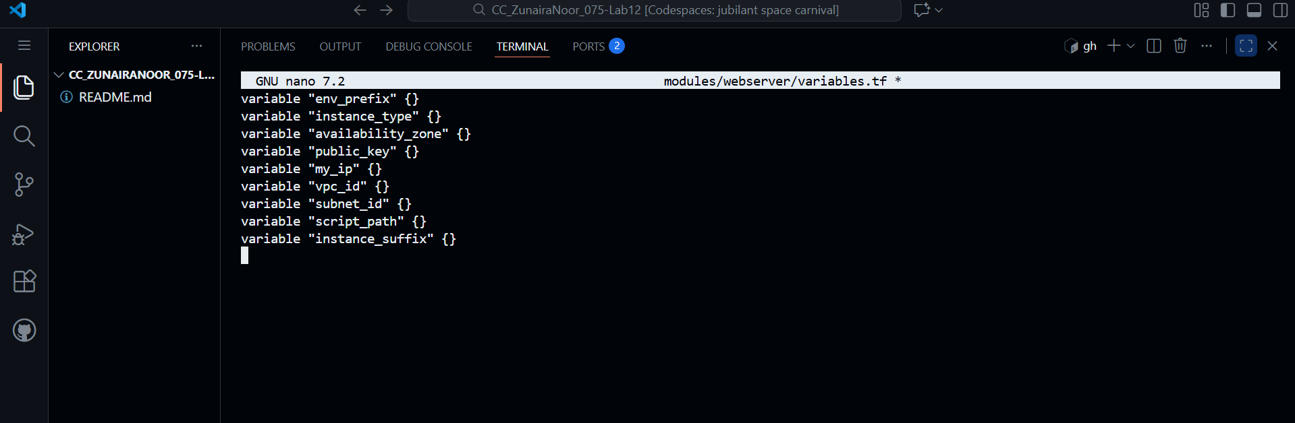

**Step 3: Create modules/webserver/main.tf**

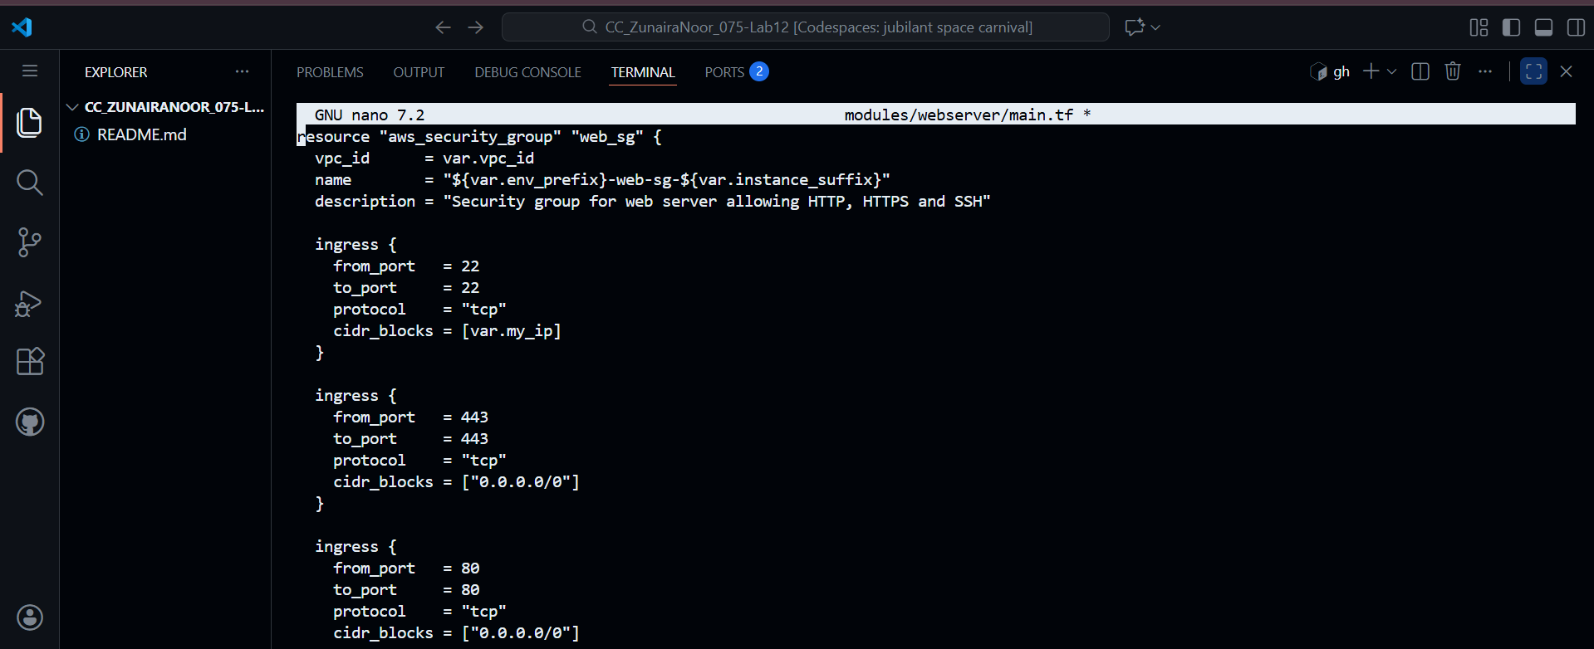

**Step 4: Create modules/webserver/outputs.tf**

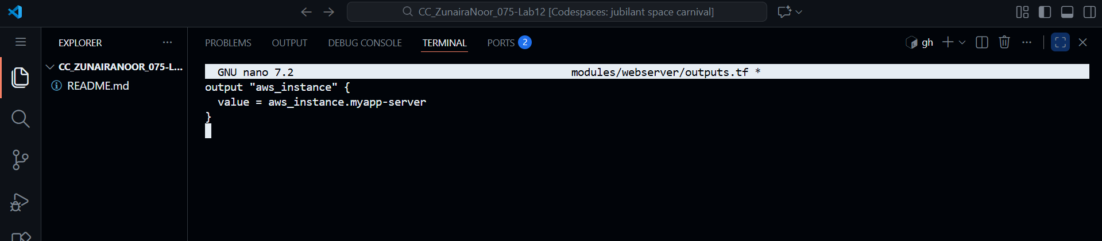

**Step 5: Modify Root main.tf**

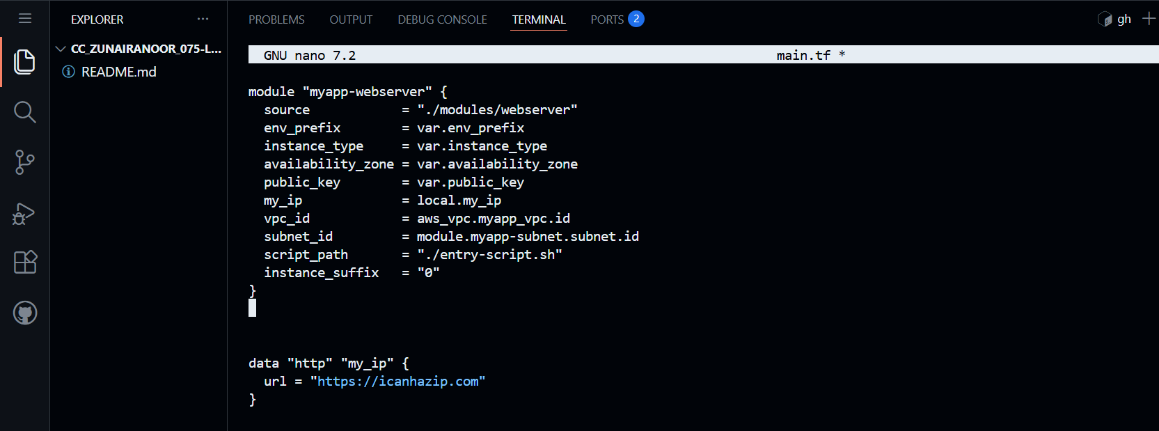

**Step 6: Update outputs.tf**

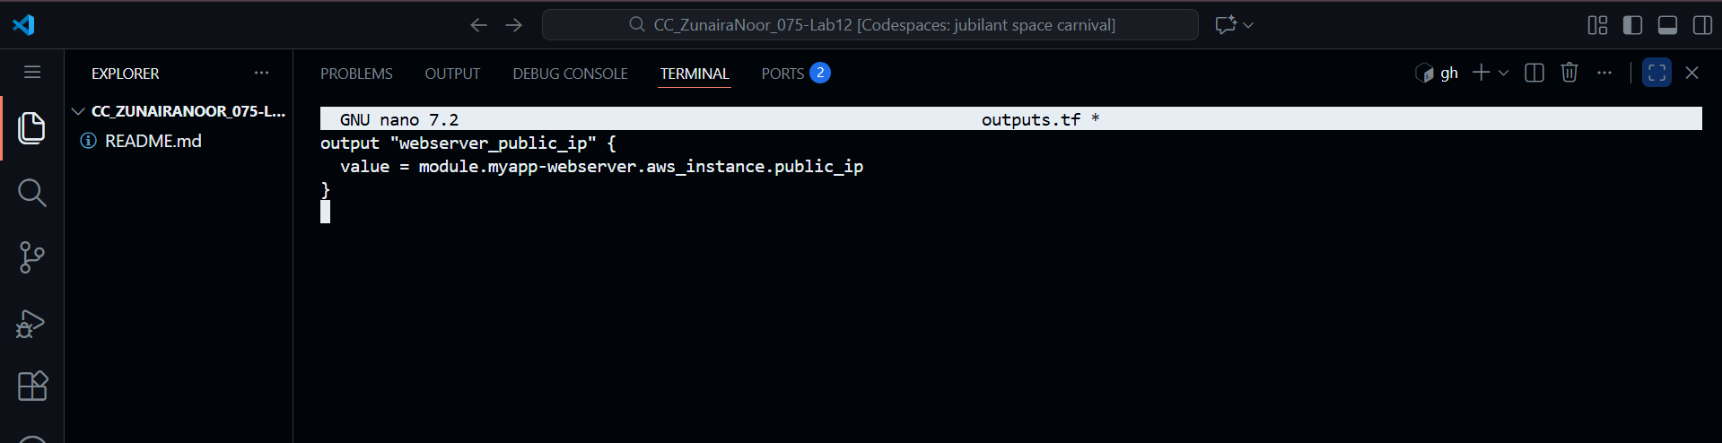

**Step 7: Initialize Terraform**

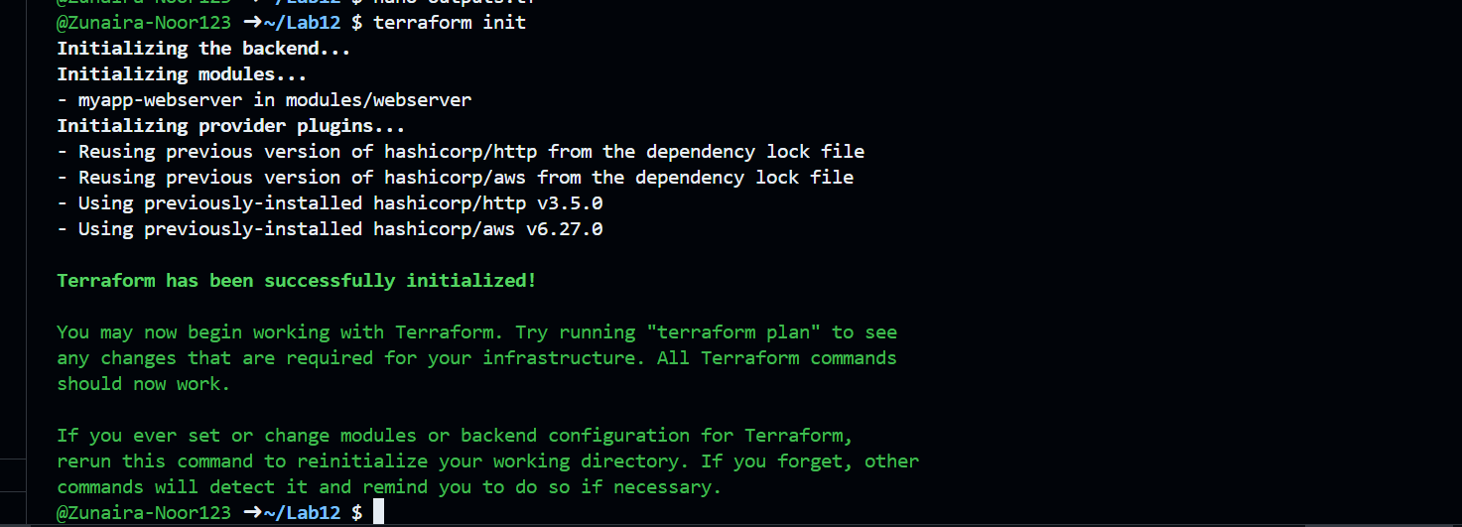

**Step 8: Apply Configuration**

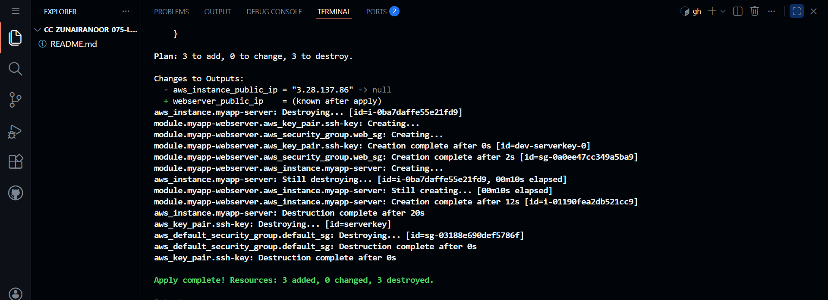

**Step 9: Display Output**



**Step 10: Test Nginx**

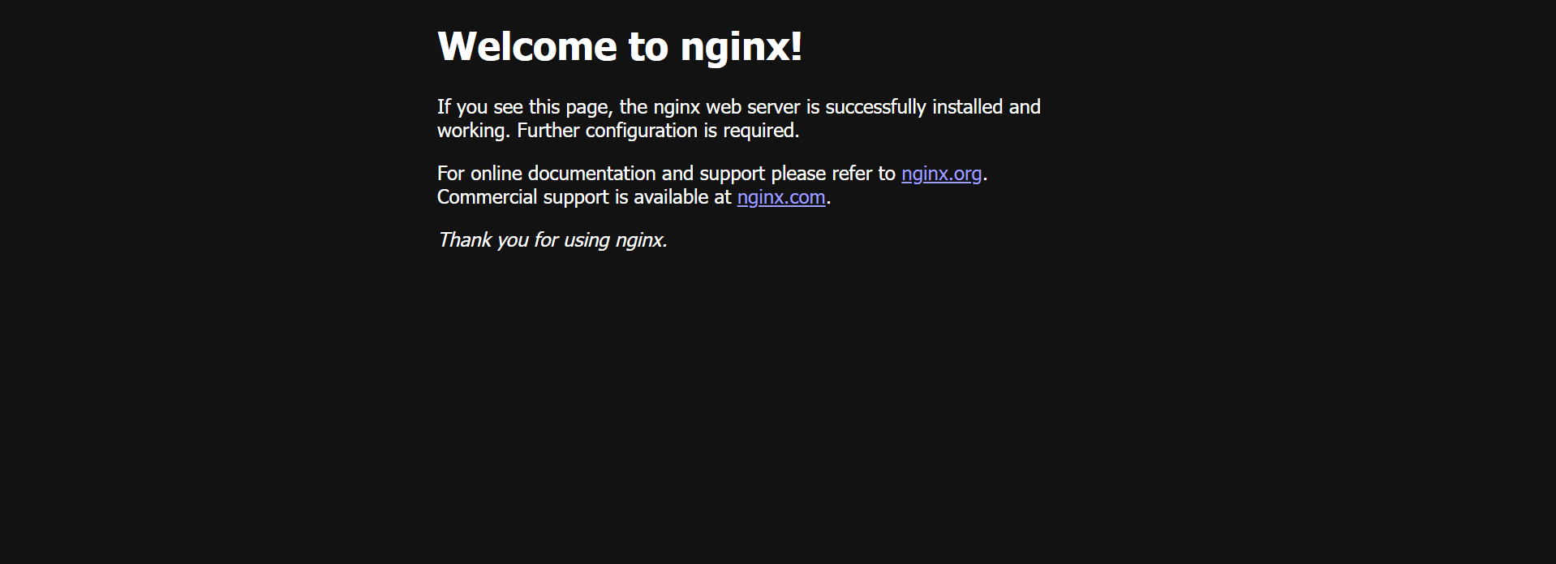

**Step 11: Destroy Resources**

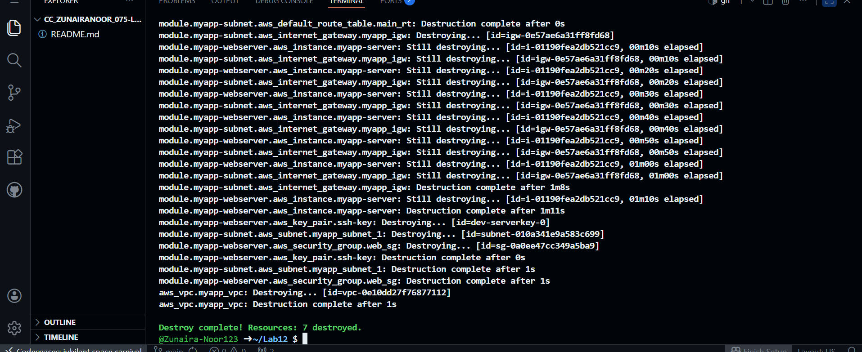

**Task 6 — HTTPS with Self-Signed Certificates**

**Step 1: Update entry-script.sh**

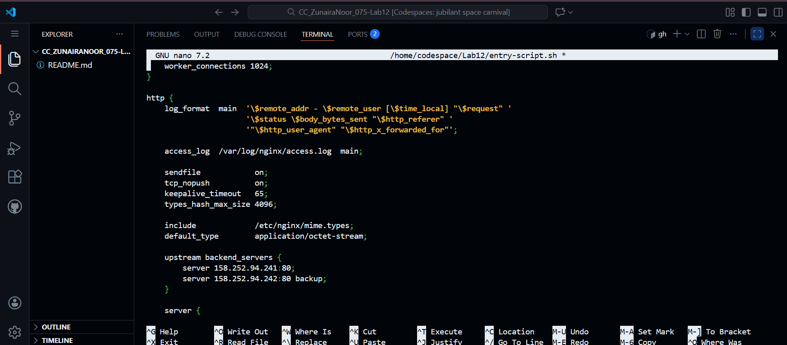

**Step 2: Apply Terraform**

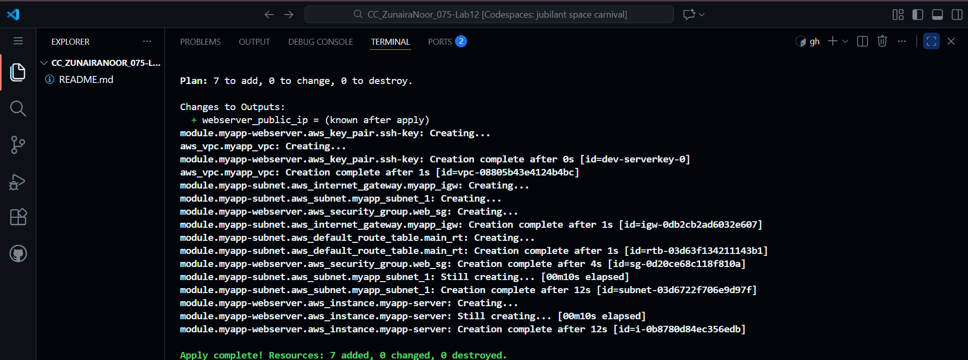

**Step 3: Display Output**



**Step 4: Test HTTPS in Browser**

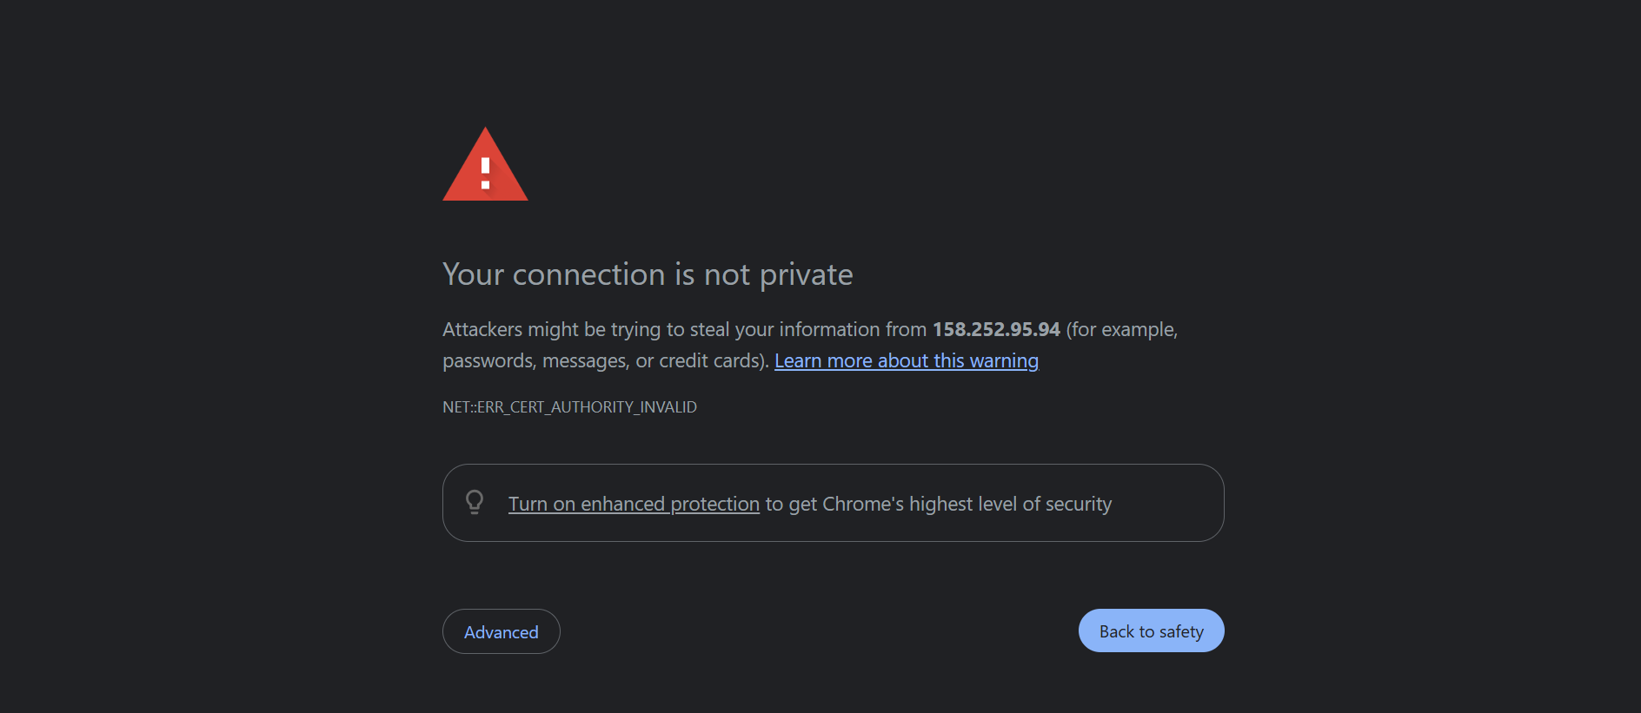

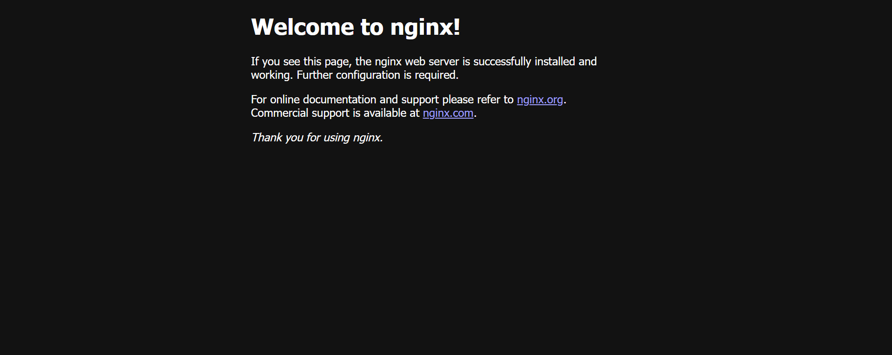

**Step 5: Verify HTTP to HTTPS Redirect**



**Task 7 — Nginx as Reverse Proxy**

**Step 1: Create apache.sh Script (Backend Web Server)**

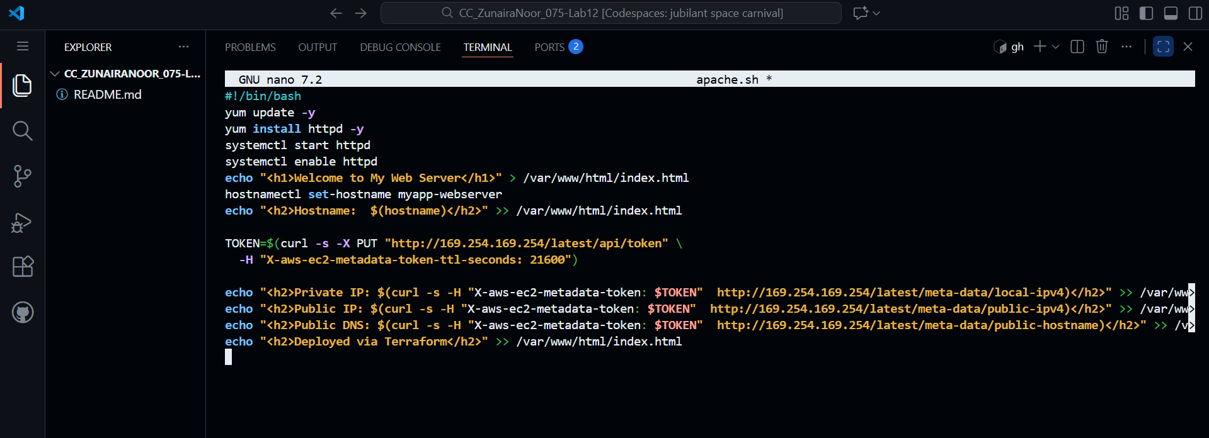

**Step 2: Add Backend Module myapp-web-1 to main.tf**

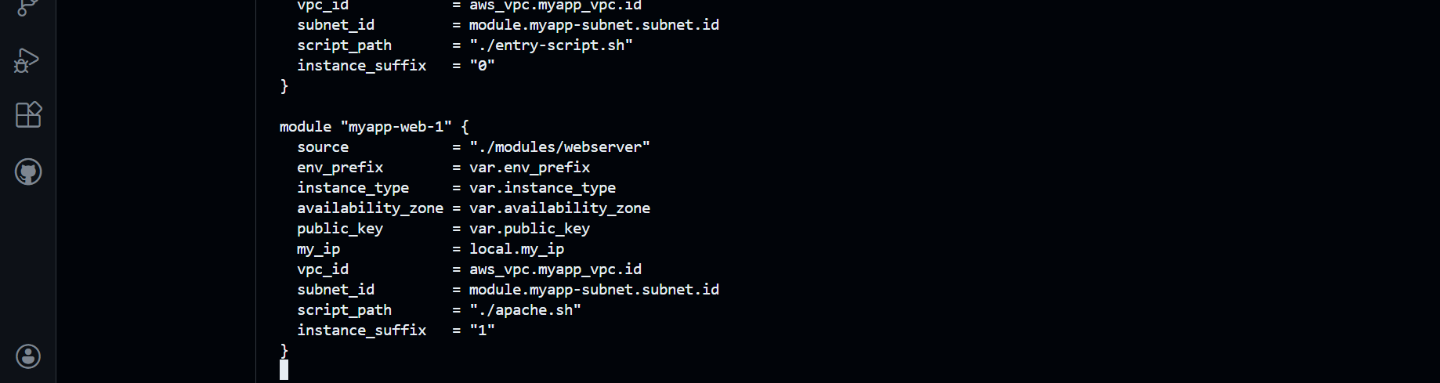

**Step 3: Update outputs.tf**

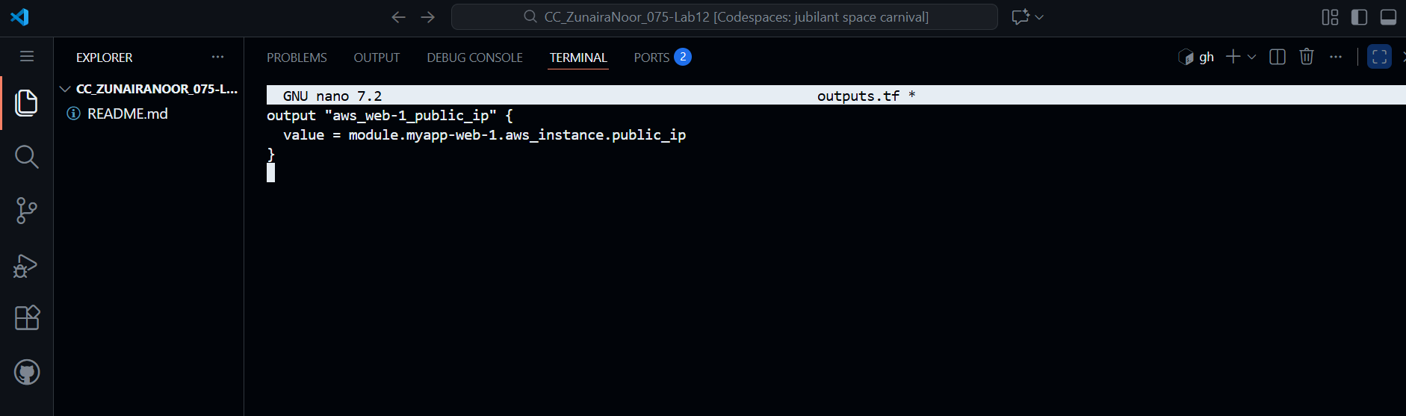

**Step 4: Apply Terraform**

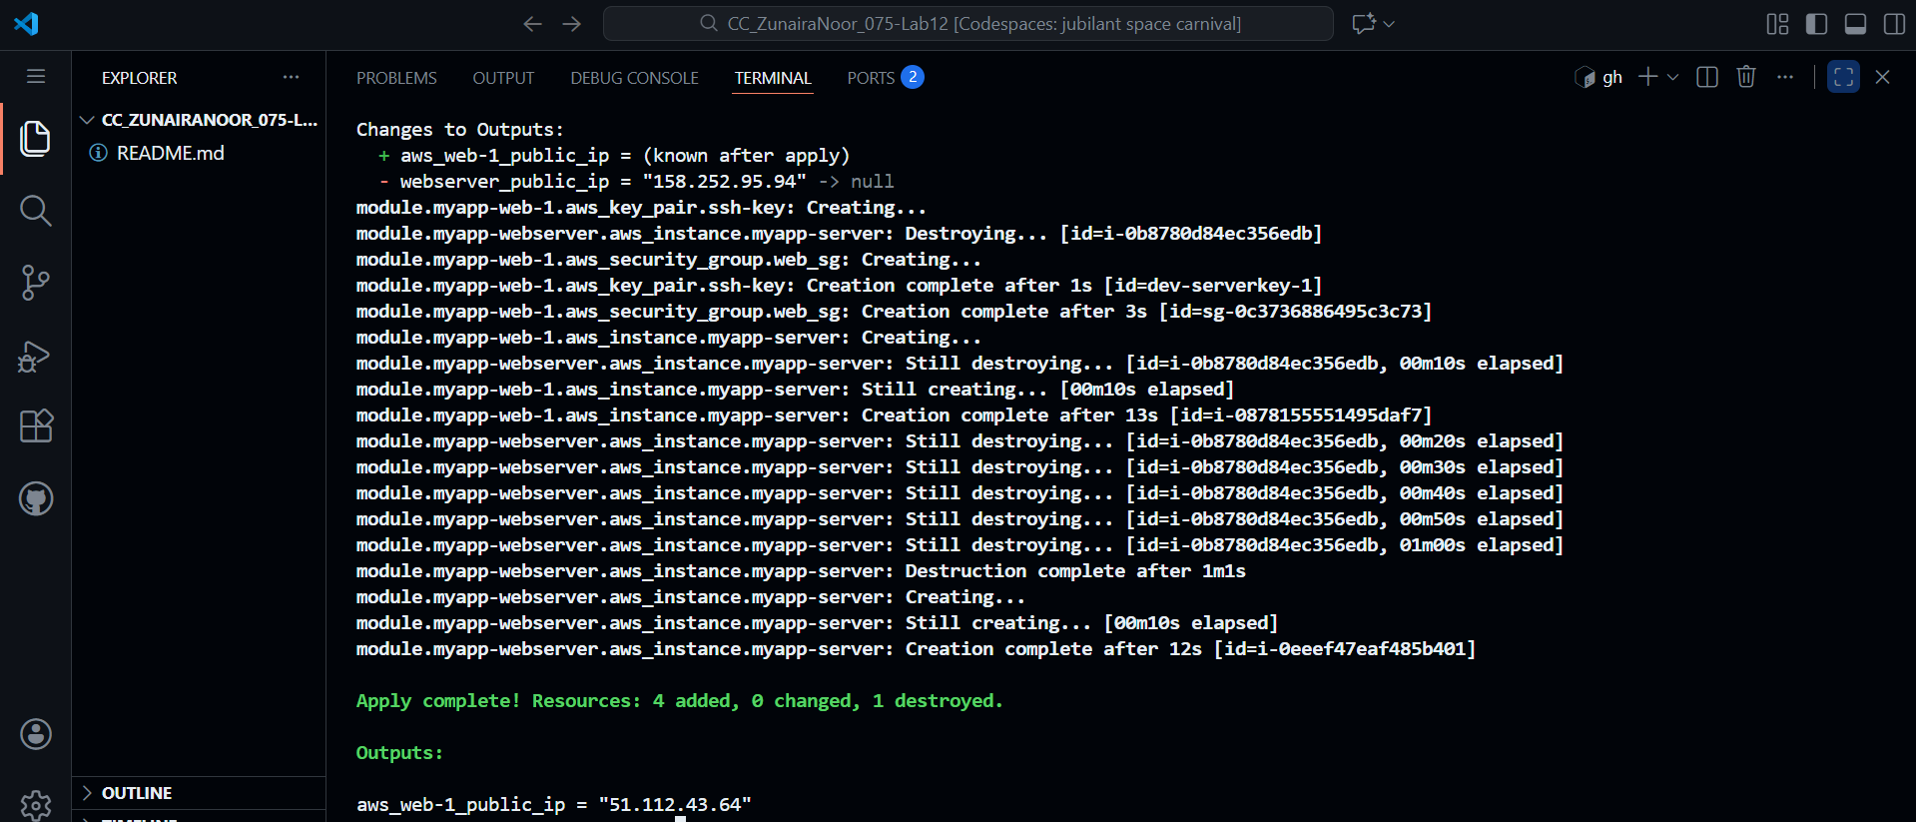

**Step 5: Get Outputs**



**Step 6: SSH into Nginx Webserver**

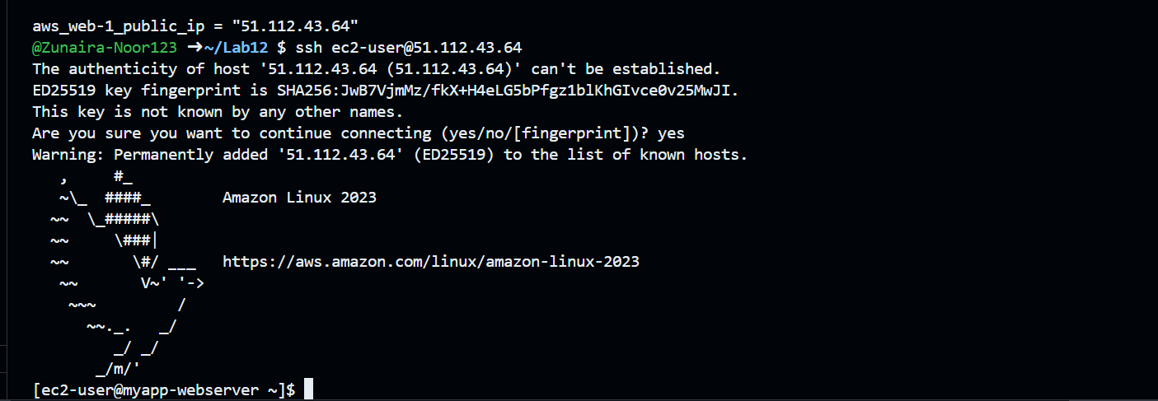

**Step 7: Edit Nginx Config for Reverse Proxy**

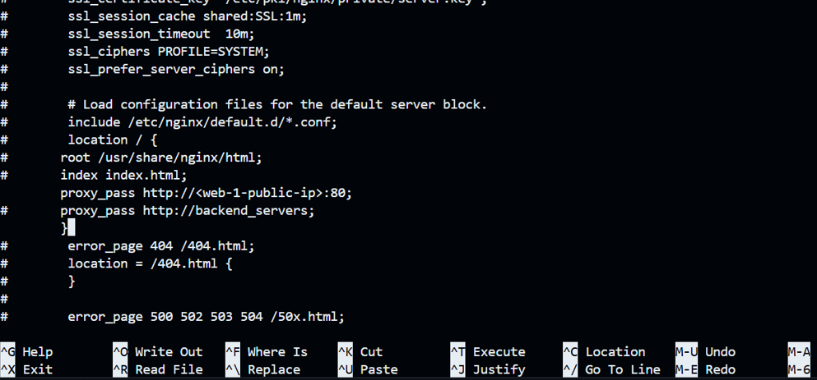

**Step 8: Restart Nginx**



**Step 9: View Nginx Logs and Files**

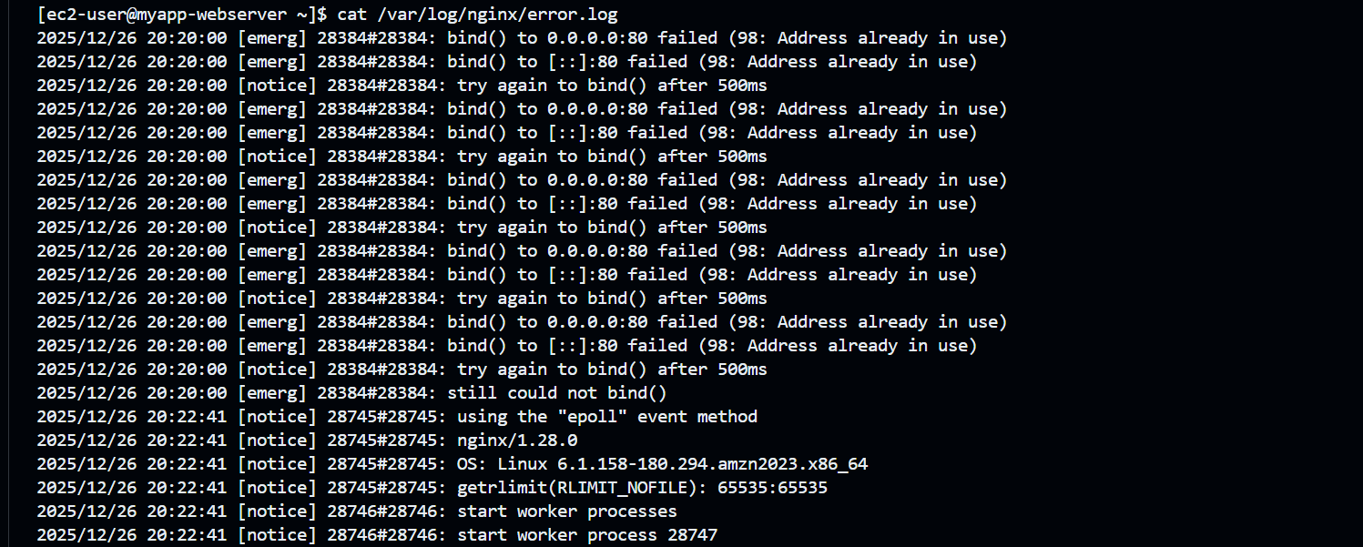

**Step 10: Test Reverse Proxy in Browser**



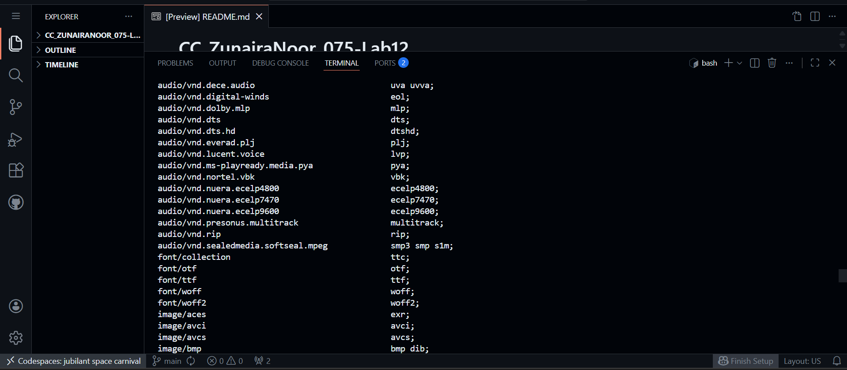

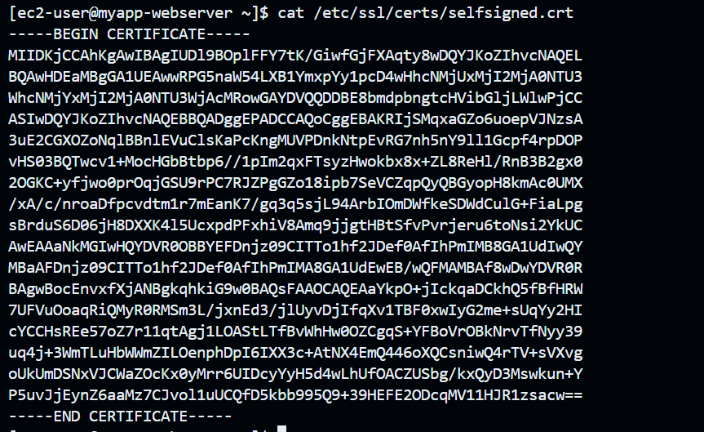

**Task 8 — Configure Nginx as load balancer**

**Apply Terraform**

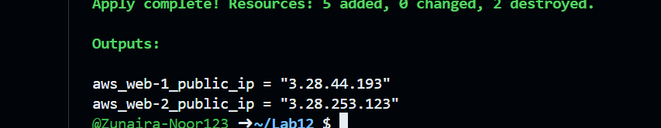

**Restart Nginx**

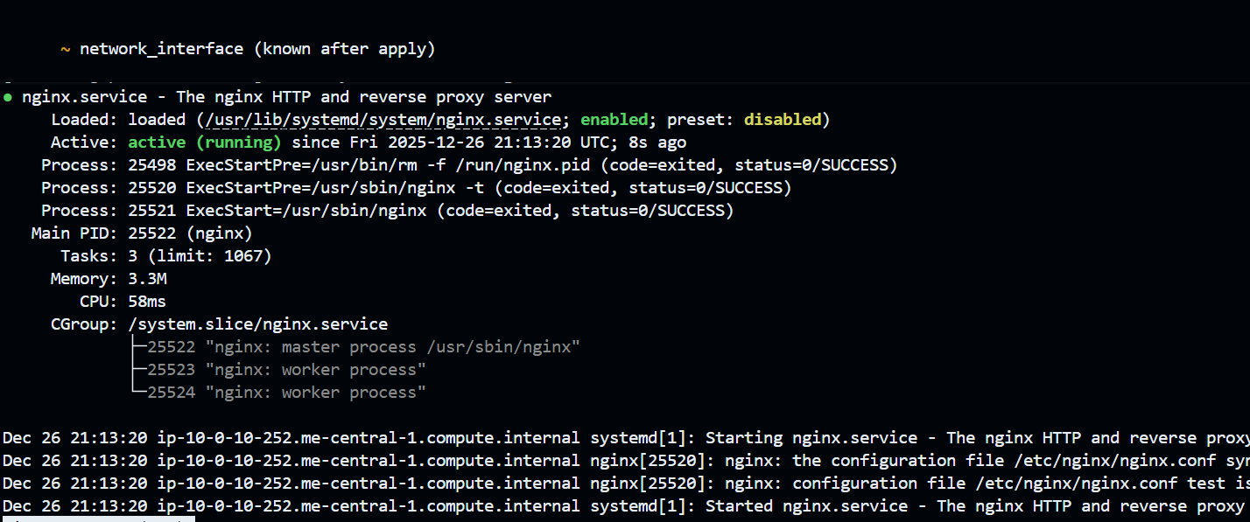

**Test load balancing**

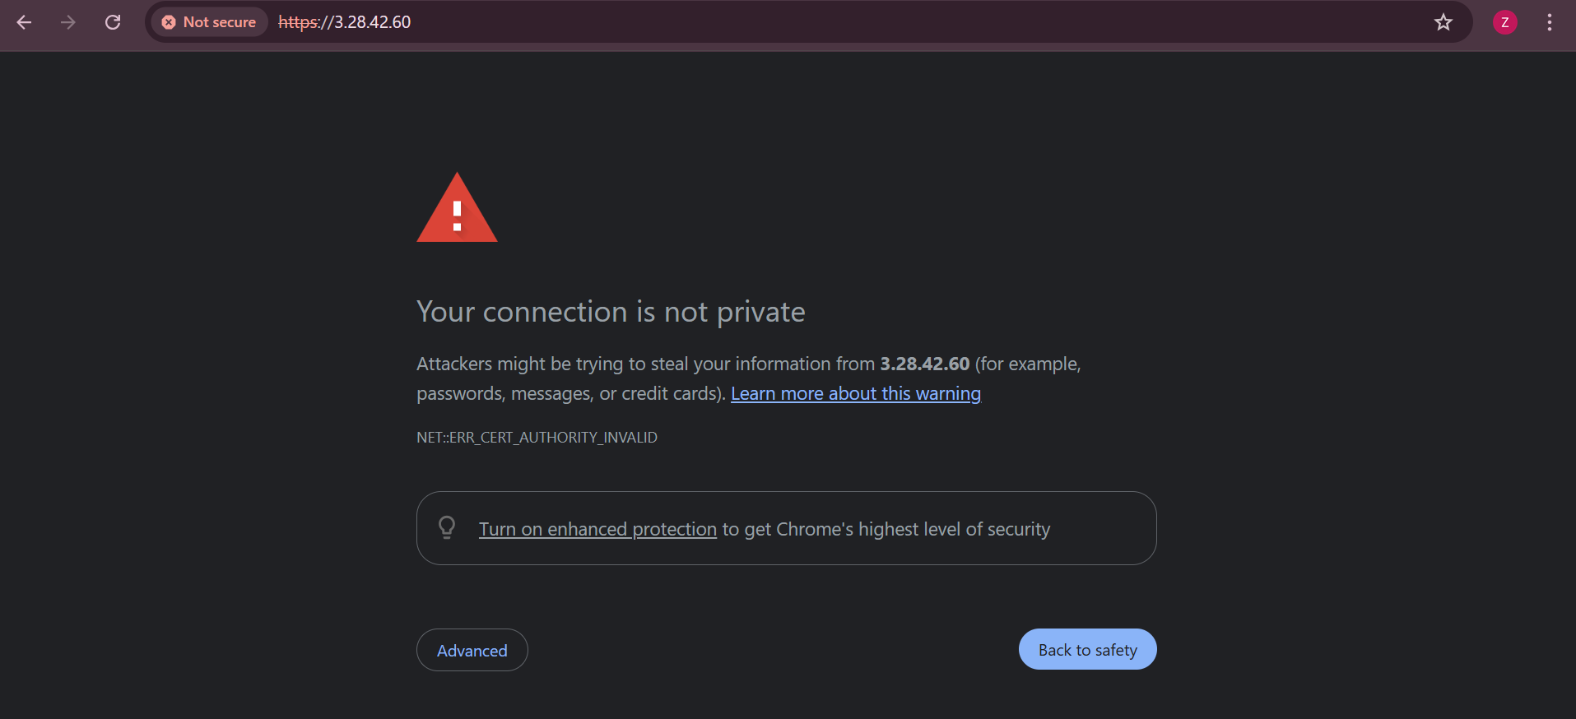

**Web1**

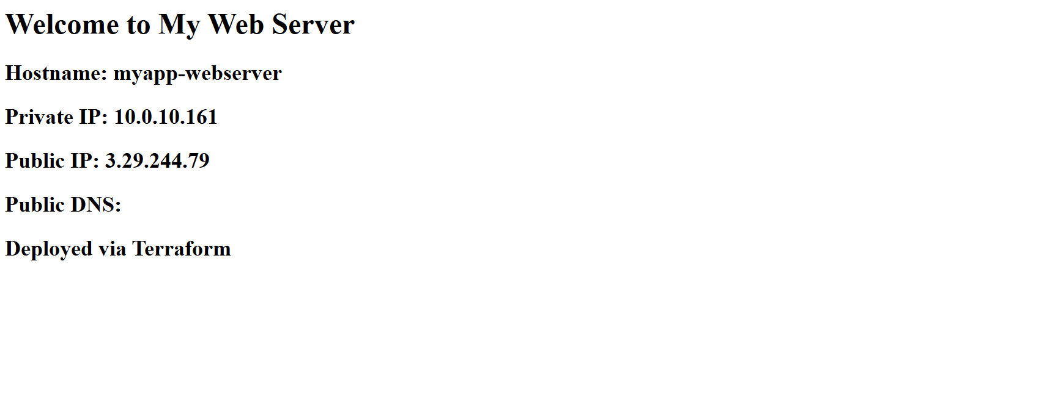

**Web2**

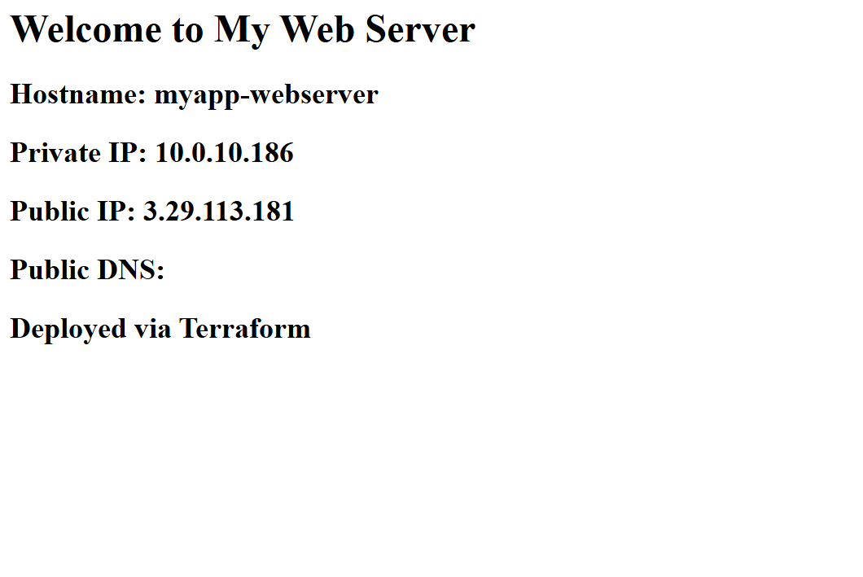

**Task 9 — Configure high availability with backup servers**

**Edit Nginx configuration for high availability:**

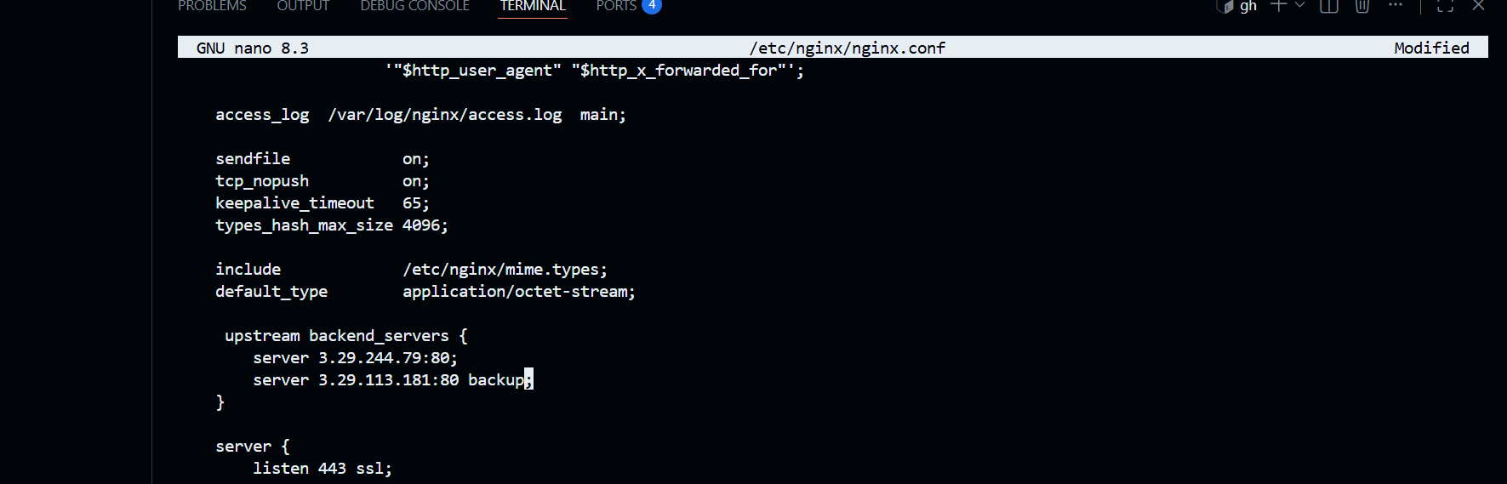

**Test in browser**

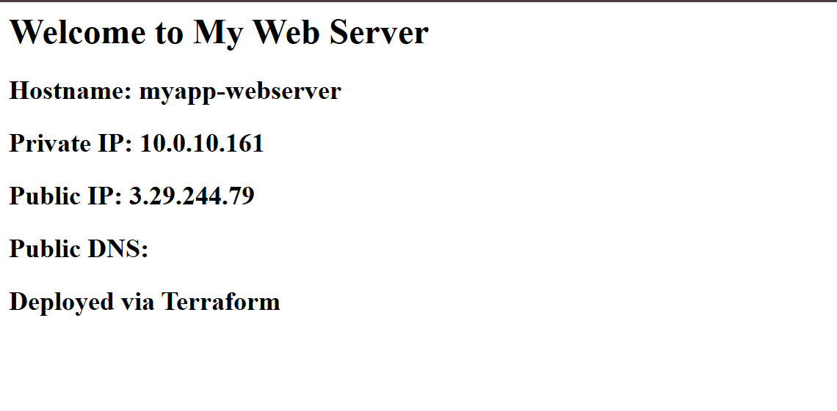

**Switch backup configuration:**

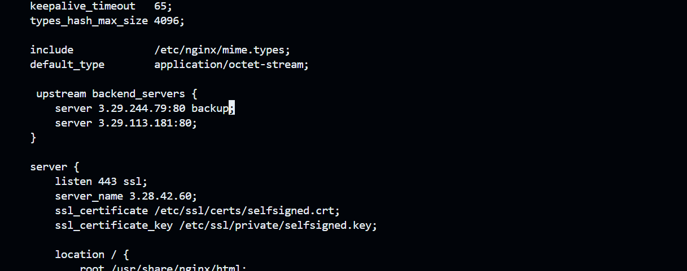

**Restart Nginx:**



**Test in browser:**

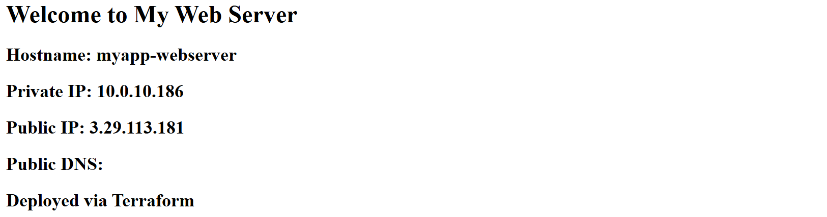

**Task 10 — Enable Nginx caching**

**Add proxy cache configuration in the http block and location block:**

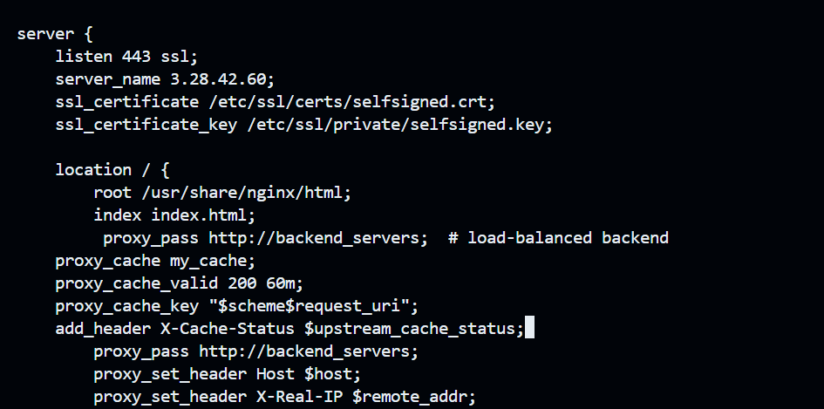

1. **Restart Nginx:**

